NATIONAL TECHNOLOGY DAY

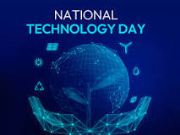

National Technology Day is celebrated every year on May 11. This date was chosen to mark the anniversary of the successful nuclear tests conducted at Pokhran on May 11, 1998. This year, National Technology Day is falling on a Saturday

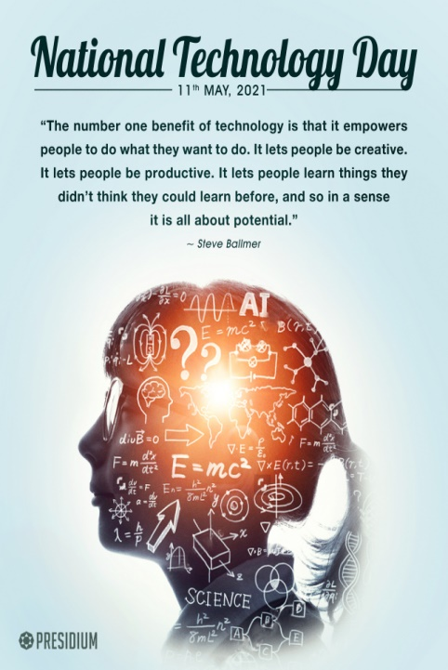

ENGINEERING

Engineering is the designing, testing and building of machines, structures and processes using maths and science. Studying it can lead to a rewarding career. Engineering is a discipline dedicated to problem solving

**TYPE OF**

**ENGINEERING**

* Aerospace Engineering
* Chemical Engineering
* Civil Engineering
* Electrical Engineering
* Computer Engineering
* Industrial Engineering
* Marine Engineering
* Biomedical engineer
* Materials Engineer
* Structural Engineering
* Agricultural
* Automobile Engineering
* Telecommunication Engineering
* Biochemical Engineering
* Nuclear engineer
* Geological Engineering
* Transportation Engineering
* Software Engineer
* Textile engineering

COMPUTER ENGINEERING



NUCLEAR ENGINEERING

Computer engineering (CoE or CpE) is a branch of computer science and electronic engineering that integrates several fields of computer science and electronic engineering required to develop computer hardware and software.

Nuclear engineering is based on fundamental principles of physics and mathematics that describe nuclear interactions and the transport of neutrons and gamma rays**. These phenomena in turn are dependent on heat transfer, fluid flow, chemical reactions, and** behaviour of materials when subjected to radiation.



Chemical engineering is a discipline influencing numerous areas of technology. In broad terms, chemical engineers conceive and design processes to produce, transform, and transport materials — beginning with experimentation in the laboratory followed by the implementation of the technology in full-scale production

CHEMICAL ENGINEERING

Electrical engineering is an engineering discipline concerned with the study, design, and application of equipment, devices, and systems which use electricity, electronics, and electromagnetism.

ELECTRICAL ENGINEERING

SOFTWARE ENGINEERING

Software engineering is the branch of computer science that deals with the design, development, testing, and maintenance of software applications. Software engineers apply engineering principles and knowledge of programming languages to build software solutions for end users.



FOOD ENGINEERING

Food engineers use their skills to design sustainable and environmentally responsible food processes for manufacturing safe, tasty, healthy, convenient food products. As consumer awareness and demand for a safe and abundant supply of food have increased so too has the need for more food engineers